Business Requirements Document (BRD)
Project Title: AI-Enabled CRM Lead Management
Created by: Vaishnavi
Date: 19/12/2025

Contents
1. Document Overview 3
1.1 Purpose of the Document 3
1.2 Project Background 3
1.3 Business Context 3
2. Business Problem Statement (AS-IS) 3
3. Business Impact 4
4. Business Objectives (TO-BE) 4
5. Scope 4
5.1 In Scope 4
5.2 Out of Scope 4
6. Stakeholders 5
6.1 Primary Stakeholders 5
6.2 Secondary Stakeholders 5
7. Assumptions 5
8. Risks 5
9. High-level Business Requirements 5
10. Success Criteria 6
11. Business Rules 6
12. Constraints 6
13. AI Usage- Business Perspective 6
14. Appendix 7
14.1 AS-IS Process Diagram 7
14.2 TO-BE Process Diagram 8
14.3 Glossary 8
14.4 Supporting Artefacts 9

Document Overview

Purpose of the Document
The purpose of this Business Requirements Document (BRD) is to define the business needs, objectives, scope, and high-level requirements for the AI-Enabled CRM Lead Management for Real Estate project. This document serves as a reference for business stakeholders and the project delivery team to ensure a shared understanding of the problem being addressed and the expected business outcomes. It provides the foundation for subsequent functional and technical design activities.

Project Background
Real estate developers operating in the Dubai market receive a high volume of sales leads from multiple channels such as property portals, developer websites, social media, referrals, and walk-ins. Due to the competitive nature of the market and the involvement of both local and international buyers, timely response and effective lead handling are critical for sales success.
Currently, lead management activities are largely manual, with leads being consolidated, assigned, and followed up by sales teams without a centralised system or structured prioritisation mechanism. This results in inconsistent data quality, duplicate leads, delayed responses, and inefficient utilisation of sales agents’ time. The lack of visibility into lead quality and agent performance further limits management’s ability to make data-driven decisions.
This project is initiated to address these challenges by introducing a centralised CRM solution supported by AI-based lead prioritisation, with the goal of improving sales efficiency, customer experience, and overall business performance.

Business Context
Dubai’s real estate market is characterised by high inbound lead volumes, intense competition among developers, and customers who expect quick and personalised engagement. In this environment, the ability to rapidly identify high-intent buyers and prioritise sales efforts plays a critical role in achieving higher conversion rates and maintaining a competitive advantage.

Business Problem Statement (AS-IS)
Currently, the real estate sales team receives leads from multiple sources which are manually consolidated by the sales developer or manager and assigned to sales agents. Lead data is often incomplete, duplicated, or inconsistent due to the absence of a centralised system.

The manual nature of the process leads to delays in contacting prospects, inconsistent follow-ups, and inefficient use of sales agent time. In some cases, the same lead may be contacted by multiple agents, negatively impacting customer experience. There is no structured mechanism to prioritise leads, making it difficult to identify serious buyers early in the sales cycle.

Business Impact
If the current process continues without improvement:
- Sales opportunities may be lost due to delayed responses.
- Sales agents may spend excessive time on low-quality or unresponsive leads.
- Duplicate outreach may negatively affect customer trust and brand perception.
- The organisation may lose potential sales to faster and more data-driven competitors.

Business Objectives (TO-BE)
- Centralise all sales leads from multiple sources into a single CRM system.
- Improve lead data quality and eliminate duplicate leads.
- Enable faster identification and prioritisation of high-intent buyers.
- Improve sales agent productivity and lead-to-sale conversion rates.
- Provide real-time visibility into lead and sales performance for management.

Scope

5.1 In Scope
- Capture leads from multiple sources relevant to Dubai real estate sales.
- Validate, cleanse, and de-duplicate lead data.
- Prioritise leads using AI-based scoring.
- Automatically assign leads to sales agents.
- Track agent follow-ups and lead status.
- Provide dashboards and reports for sales agents and developers.

5.2 Out of Scope
- Payment processing and financial transactions.
- Legal documentation, property registration, and compliance activities.
- Property construction and inventory management.
- Marketing campaign execution and promotional messaging.

Stakeholders

6.1 Primary Stakeholders
- Sales Agents
- Sales Manager / Sales Developer

6.2 Secondary Stakeholders
- Business Analyst
- Project Manager
- Development Team
- QA / Testing Team

Assumptions
- Lead data will be available from existing sources such as portals, websites, and referrals.
- Regulatory and legal requirements are managed outside the scope of this project.
- Sales agents will adopt the CRM system for daily lead management activities.
- Historical lead data (or simulated data) will be available to support lead scoring and analysis.

Risks
- Customer data privacy and data protection risks.
- Poor-quality or incomplete lead data impacting prioritisation accuracy.
- Resistance from sales agents to adopt new CRM workflows.
- Initial AI lead scoring accuracy may be limited due to insufficient historical data.

High-level Business Requirements
- The system should capture and consolidate leads from multiple sources.
- The system should store all lead information in a centralised repository.
- The system should assess and improve lead data quality.
- The system should prioritise leads based on likelihood to convert.
- The system should automatically assign leads to appropriate sales agents.
- The system should support follow-ups and lead status tracking.

Success Criteria
- Reduced lead response time, especially for high-priority leads.
- Improved lead-to-sale conversion rate.
- Better utilisation of sales agent time.
- Improved visibility of lead quality and sales performance for management.

Business Rules
- Leads must be prioritised using AI-based lead scoring.
- Each lead must be assigned to only one sales agent at a time.
- Follow-up attempts for a lead must be limited to a minimum of two and a maximum of three attempts before marking the lead as unresponsive.

Constraints
- Real estate sales cycles in Dubai can be long and variable.
- Sales agents may require training to effectively use the CRM system.
- Availability and accuracy of historical lead data may be limited initially.

AI Usage- Business Perspective
AI is used in this project to support lead prioritisation and decision-making, not to replace human judgement.
AI Purpose
- Identify high-intent buyers early.
- Reduce subjective judgement in lead qualification.
- Improve response speed for premium prospects.
AI Inputs
- Lead attributes such as budget, property type, and preferred location.
- Purchase timeline.
- Engagement behaviour and interaction history.
- Lead source performance trends.
AI Outputs
- Lead score (e.g., 0–100).
- Priority category: High, Medium, or Low.
Business Value
- Faster engagement with serious buyers.
- Reduced effort spent on low-quality leads.
- Improved conversion rates in a competitive market.

Appendix

14.1 AS-IS Process Diagram
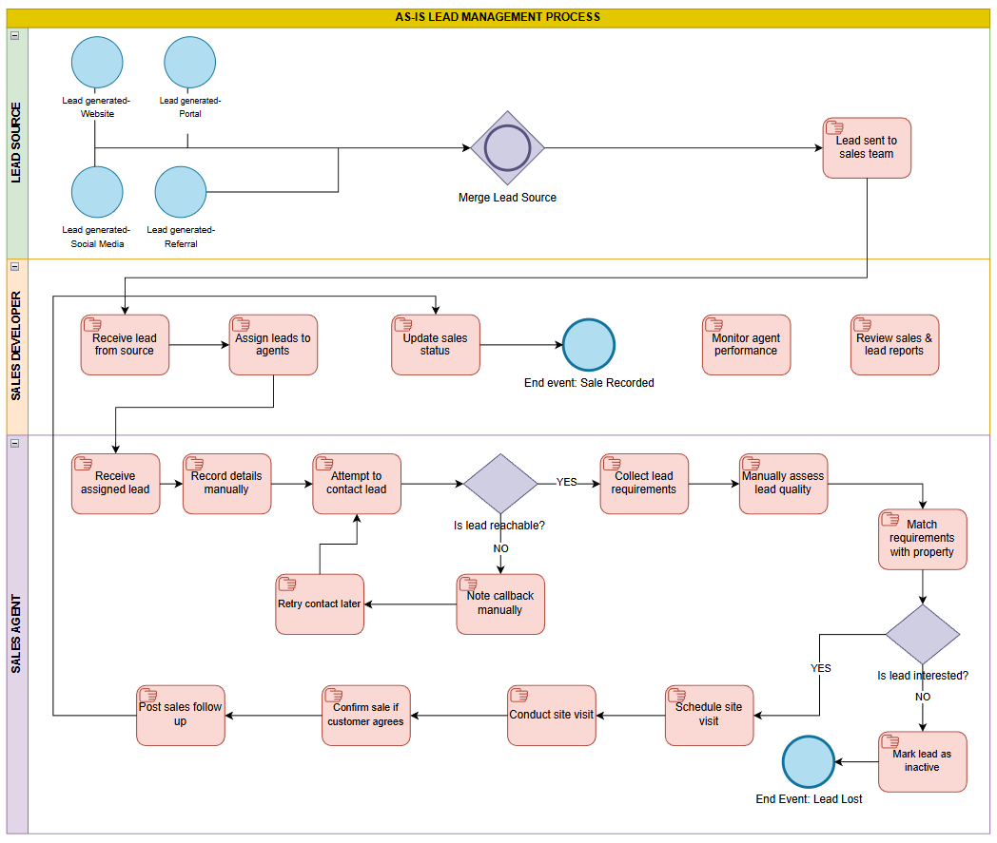

14.2 TO-BE Process Diagram
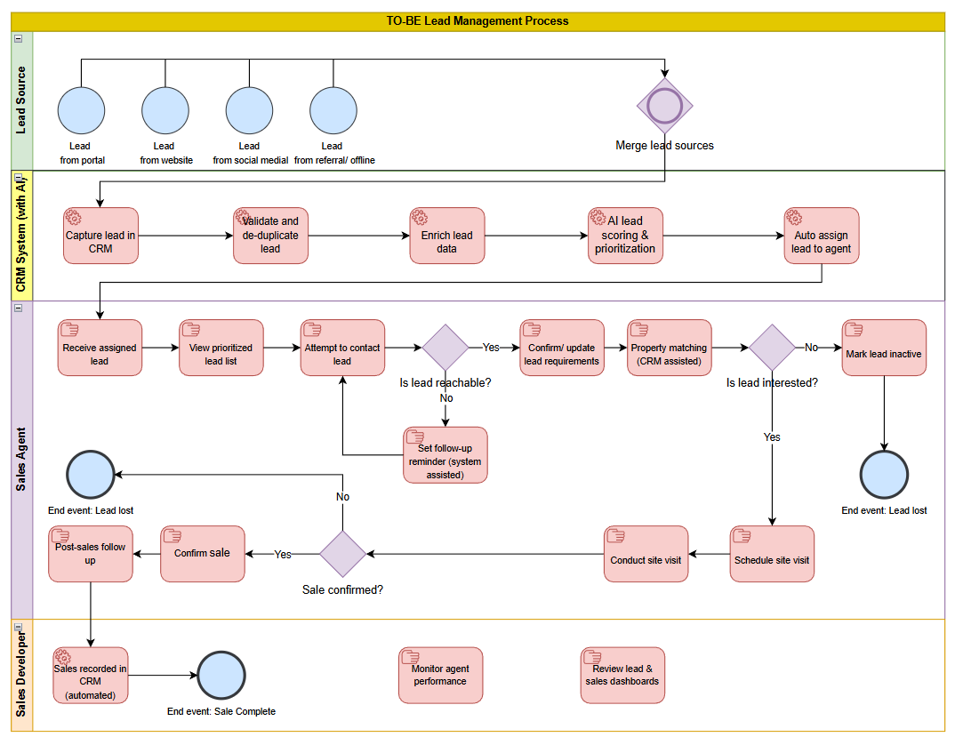

14.3 Glossary
Term | Definition
CRM (Customer Relationship Management) | A system used to store, manage, and track customer and lead information.
Lead | A potential customer who has shown interest in a real estate property.
Lead Scoring | The process of assigning a score to leads based on their likelihood to convert.
Lead Prioritisation | Classification of leads (High/Medium/Low) to determine agent focus.
High-Priority Lead | A lead with high likelihood of conversion based on defined criteria.
Duplicate Lead | Multiple lead records referring to the same customer.
Sales Agent | A user responsible for contacting leads and converting them into sales.
Sales Manager / Developer | A user responsible for overseeing sales operations and performance.

14.4 Supporting Artefacts
- Sample lead dataset (CSV / Excel)
- Sample dashboard screenshots
- High-level SQL queries used for reporting

